DCFabric: An Open Source SDN Controller for Cloud Computing Data Centers

White Paper

Shanghai Engineering Research Center for Broadband Networks and Applications

- SDN is the main trend of future network technology development
Nearly 2/3 of global network load will be processed on the cloud in 2016 and data centers (DC) are becoming the sources or destinations of most internet traffic. Because the internal traffic of data centers which is mainly produced by the storage and data switch operations among virtual machines takes up 76% of its total traffic, the cloud computing data centers are turning out to be the core of future internet. However, in current data centers, each service has to be separated from others physically and develops on its own since various network services use the resource independently and almost no resource movement is required. Therefore, the scalability of data centers is limited, which means there is no other way except for changing the network devices longitudinally if improvements are required, and no lateral extension will be allowed. Hence, the system performance always has a bottleneck like this: for taking care of 1% peak traffic, 99% of machines will be involved, but the efficiency of each machine is less than 20%.
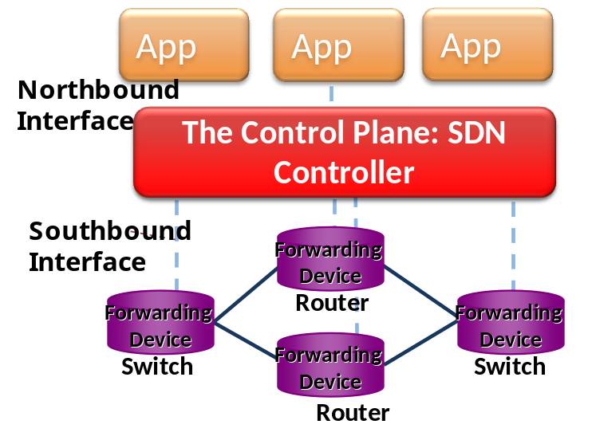
Fig. 1. The three layers of a SDN network
In order to support large scale network construction, obtain the unified management on physical and virtual nodes, realize rapid multi-tenant and multi-service deployments, make each device a white box and achieve effective traffic engineering and resource utilization, software defined networking (SDN) was proposed as a key technology for future network development. The principle idea of SDN is to separate the data plane from the control plane, which is realized by using a SDN Controller to centrally control the behaviors of forwarding devices via open programmable interfaces. As a result, SDN divides the traditional network architecture into three layers: the application layer, the control layer and the forwarding layer, as shown in Fig. 1.
The functions of the control layer are implemented by the centralized SDN Controller. The Controller performs as a bridge that connects application layer and forwarding layer by means of providing open networking operation system (NOS) interfaces: the northbound interface that faces the application layer is programmable, and the southbound interface is employed for the interactions between the Controller and forwarding layer based on protocols like OpenFlow. The application layer consists of many software application programs, so the network administrators or developers only need to care about the logic of applications rather than pay attention to the details of lower layers. The main work of the Controller is to configure and manage the devices of forwarding layer according to the specific application demands. Based on the centralized management, the Controller can control the rate and the direction of the traffic in real time, realize virtual management on the network bandwidth resource and components as well as support the transformation from extensive growth of network module to fine-grained extension of resource pool, which improve the network resource utilization greatly. As for the forwarding layer, it merely executes actions according to the commands or strategies from control layer. As a result, the SDN can employ the new services or protocols flexibly without changing or replacing any hardware devices. This reduces many complex functions originally assigned on the network devices. Therefore, SDN not only facilitates the realization and deployment of new network technologies and protocols, but also highly promotes the flexibility and operability of network.
The idea of SDN subverts current internet architecture completely, making the network transform from a longitudinally integrated and closed state to a laterally integrated and open ecosystem that supports rapid creation. The programmable capability of SDN is flexible, which not only improves the automated managements and control performances of network, but also solves some existing problems. For instance, the scale of resource is limited, the flexibility of networking is not ideal, and the requirements of services is hard to be met quickly. Therefore, SDN is helpful to improve the innovation and development of the network. Till now, SDN has drawn greater attention and become a research hotspot since it was first proposed in 2009. The implementation of SDN technology makes applications having the capability of flexibly operating and managing all kinds of network facilities. By doing so, SDN will not be limited by traditional routing protocols while formulating service policies. Instead, SDN can provide intelligent services for the network based on the elements that are close to the upper application, such as service awareness, user demand, network congestion and transmitting ability of services. Hence, with internet+ and big data becoming the social hot spots nowdays, as the core of SDN, how to design an effective SDN Controller for cloud computing data centers is becoming a key point.
- DCFabric: an open source SDN Controller for cloud computing data centers
Although some SDN Controllers, including NOX, Beacon, SNAC and POX, are helpful to explore the potential of SDN, they are not qualified to become commercial products due to their poor performances such as restricted scalability and limited usability, etc. Moreover, because their programming interfaces and abstractions used for devices are more primitive, they are limited in terms of supportable application category, scope of application, safety and stability, etc. Hence, those Controllers are more likely to be drivers. ODL and ONOS have better topology performances and both of them are easier to be developed. However, their flexibilities, working speeds and efficiencies are still need to be improved. Therefore, with the arrival of big data, a SDN Controller which can be easily developed and having better performance and higher efficiency is necessary for cloud computing data centers.
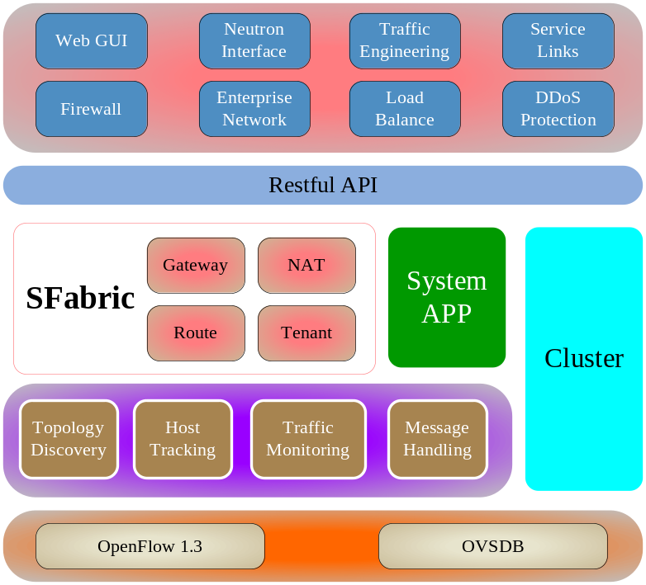
Fig. 2. DCFabric: an open source SDN Controller for cloud computing data centers
For this reason, we design an open source SDN Controller for cloud computing data centers, named DCFabric. It can be divided into five layers from top to bottom (see Fig. 2): the first layer is the Web application layer supported by DCFabric, the second layer is the northbound interface layer, the third layer is the system app layer that contains a novel SFabric module, the fourth layer is the basic service layer that guarantees the good running of the upper applications, the fifth layer is the southbound interface layer based on several protocols like OpenFlow.
The Web applications supported by DCFabric mainly include Web GUI, Neutron interface, traffic engineering, firewall, load balance, DDos protection and so on. Accordingly, DCFabric is able to provide a series of supports for data centers with network management, virtualization, security and traffic control, etc.
Restful API is the northbound interface provided by DCFabric for application developers. It separates the network applications from network details, making all kinds of facilities, events (i.e. link interruptions) and specific operations transparent to the application programs. Consequently, data centers can improve users’ experience and realize intelligence and safety by various flexible network applications.
The system app of DCFabric is going to centrally handle the logical processing and generate specific flow entries according to upper applications, lower basic services (topology discovery, host tracking, traffic monitoring and message handling, etc.) and its internal execution strategies. After that, DCFabric installs those flow entries into switches via OpenFlow or OVSDB. Thus, each switch only needs to execute corresponding actions in accordance with flow entries when processing the packets. Compared with other existing SDN Controllers, DCFabric has the following two different characters:
- The SFabric module: Different from other SDN technologies that compute routes on the host level, DCFabric can compute routes on the switch level with the help of SFabric module. Since the number of switches in a network is much less than that of hosts, SFabric can greatly reduce the flow entries and the working load of DCFabric, bringing the benefit of accelerating the speed of DCFabric (please see Chapter 3.1 for details). Because DCFabric has better efficiency on dealing with gateway, route, network address translation (NAT), multi-tenant management and etc., it can achieve effective control and management on cloud computing data centers whose scale is still rising.
- Support for redevelopment: DCFabric also supports the redevelopment of system app, which allows other developers improving parts of the functions of DCFabric on their specific demands. Therefore, DCFabric has better compatibility and applications.
Moreover, considering the limited working capability of a single Controller, in order to cope with increasing network scale and guarantee its stability, the deployment of cluster Controllers is supported. Therefore, if one Controller is down, the related SDN switches will connect with another Controller as soon as possible. Furthermore, multiple Controllers can work as a logical entity due to their good cooperation, which makes the data plane transparent to application programs. Therefore, the deployment of cluster Controllers make great contributions to the high throughput, low delay, good flexibility and strong stability of data centers.
- Main characters of DCFabric
- Efficient capability of constructing scalable large layer 2 network based on SFabric
SDN Controller is good for significantly enhancing the network resource utilization. However, with the enlargement of data center scale, there is still a main problem in most of the existing SDN Controllers: the flow entries stored in each switch increase with the numbers of switches and hosts (Theoretically, the flow entries of a switch are able to cover all hosts in the network at most), which not only demands larger storage capability and faster query speed of the switch, but also puts forward higher requirement on the efficiency of the SDN Controller.
  - The architecture of SFabric
In order to solve above problems, we improve the current SDN technologies and design a novel SFabric technical architecture, which can alleviate the working load of the SDN Controller and highly improve its efficiency.
In SFabric, all switches are guided by DCFabric to find their neighborhoods by using the link layer discovery protocol (LLDP). Since the host will neglect LLDP messages automatically, therefore each switch knows the neighboring switches that directly connect to it. After obtaining the information of all switches, DCFabric has the full knowledge of the network topology. In the next step, DCFabric computes a path for each pair of switches (note that the path does not have to be the shortest path due to the consideration of load balance) and then assigns a specific tag for all the paths having the same destination switch (the switch that directly connects with the destination host). At last, DCFabric will install the path information into the switches along the path in the form of flow entry. Thus, the switches along the path know how to forward packets according to the tag. As shown in Fig. 3, supposing that the paths from switch 1 to switch 2, 3, 4 and 6 are 1→2, 1→3, 1→2→5→4 and 1→3→4→6, respectively, the flow entries of switch 1 are listed at the bottom of Fig. 3. For example, the fourth flow entry indicates that the packets with tag 6 (its destination switch is switch 6) will be output via port 2 of switch 1. Therefore, SFabric will rapidly help DCFabric to construct routes on switch level in real time and prepare end-to-end unicasting paths in advance.
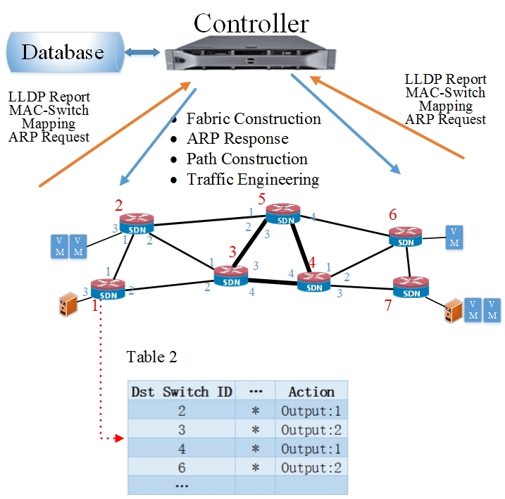
Fig. 3. The architecture of SFabric
In order to be compatible with most of OpenFlow switches, SFabric allows using VLAN id or MPLS label to represent the switch id. Since OpenFlow can support multiple flow tables from version 1.1, we build up a packet processing pipeline involving four flow tables in each switch for implementing, as shown in Fig. 4. In the following, we will describe how to install the flow entries into the four tables by assuming VLAN id is used.
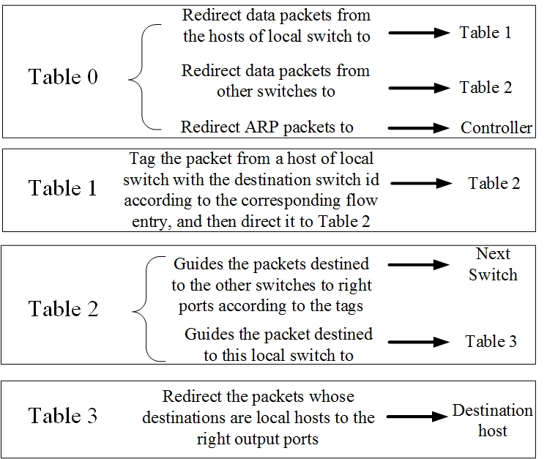
Fig. 4. The four flow tables of each switch in SFabric
Table 0 affords the work of packets preprocessing, which will redirect packets to different steps of pipeline. It has q+2 flow entries, where q is the quality of the switch ports that connect with neighboring switches. The first q entries are as “port=i, ip, actions=goto table:2”, where i is one of those ports (1≤i≤q), which are responsible for redirecting the packets from other switches to Table 2. And the left two flow entries are “ip, actions=goto table:1” and “arp, actions=Controller”, which are used for redirecting the packets from local host to Table 1 and DCFabric, respectively.
Each packet needs to be tagged in the source switch before transmission. Thus, Table 1 stores the flow entries to do that work. Therefore, Table 1 is empty after initiation, whose flow entries are session-based and added in following network communication.
Table 2 is in charge of forwarding packets according to the switch ids stored in them. There are at most s flow entries in Table 2. The first s-1 entries output the packets to different ports according to the corresponding tags, and are as “dl vlan=i, actions=output:j”, where s is the total number of switches in the networks, and i is one of VLAN ids and j is one of port of local switch. The last flow entry, which removes the tags of the packets destined to the local hosts and then redirect them to Table 3, is as “dl vlan=k, actions=pop vlan, goto table:3”, where k is the switch id of the local switch.
Table 3 is responsible for the packets destined to the local hosts of the switch, which will output the packets to the right local ports according to the Mac or IP addresses. Table 3 is also empty after the initialization, and a flow entry is installed once a local host is discovered.
  - Unicasting Path construction
Because the topology based on switch level has been constructed previously, DCFabric has the chance to optimize the procedures of constructing unicasting paths for packets. Thus, DCFabric only needs to deal with the communication demands destined to the same host in one time, which significantly reduces the number of total flow entries in the network and the working load of DCFabric. Here is the detail.
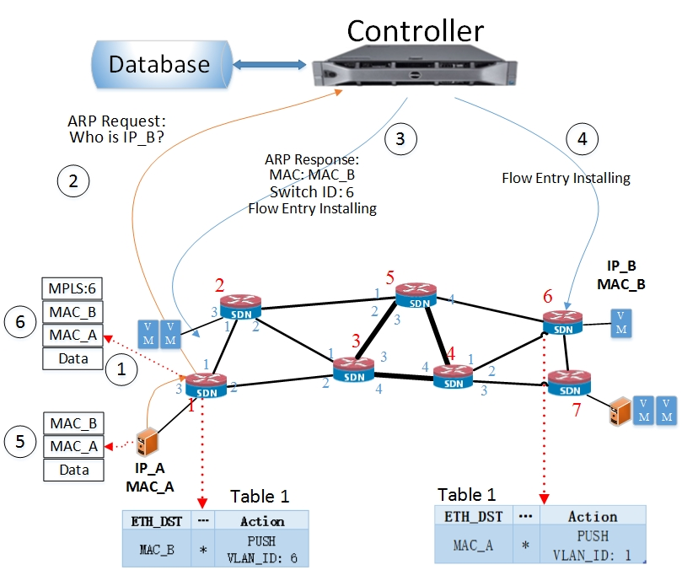
Fig. 5. The process of unicasting path construction for two hosts
Once DCFabric receives a packet-in message from a switch caused by an ARP request, DCFabric has to locate the source and destination hosts correctly as soon as possible. If the information of the requested destination host has not been stored in the database of DCFabric, DCFabric will flood the ARP request packet to all the ports of switches. Note that once DCFabric has learned the information of a new host (its information never exists in the database of DCFabric before), either receiving an ARP request or an ARP response, it will install one flow entry into Table 3 of the access switch. Fig. 5 depicts the process of a unicasting path construction for host A (directly connects with switch 1) to host B (directly connects with switch 6), which is initiated by host A. Step 1 and 2 represent the transmitting of the ARP request packet. After receiving the ARP response of host B, DCFabric installs two flow entries into Table 3 of switch 1 and 6 (in step 3 and 4). Their formats are “ip, nw_dst=IP_A, actions=output:3” and “ip, nw_dst=IP_B, actions=output:1”, respectively. The former one means that the packets whose destination is host A needs to be output from port 3 of switch 1, and the latter one indicates that the packets whose destination is host B needs to be output from port 1 of switch 6.
Afterwards, DCFabric sends an ARP responding message to host A and install two flow entries into Table 1 of switch 1 and 6, respectively, as shown in the bottom of Fig. 2 (step 3 and 4). For instance, the Table 1 of switch 1 shows that the packets destined to host B will be tagged with id 6 (step 5 and 6) of the destination switch. Then, other switches along the path will forward packets according to the tag. Lastly, at the access switch of host B (switch 6), the VLAN id is popped and packets are sent to host B. The opposite process of packet transmitting from host B to A is similar, but the tag is replaced by id 1.
Therefore, DCFabric can know the states of all switches (i.e. new switch joining or old switch leaving) in real time and construct new topology and switch route rapidly based on partial network adjustment in an incremental updating manner.
  - Scalability of SFabric
SFabric has good scalability, especially suitable for supersized data centers containing millions of hosts. Usually, the more hosts or switches in the network, the larger TCAM table a switch needs to maintain, which makes the cost increase and the efficiency decrease. As a result, the number of flow entries becomes a key factor for evaluating the scalability of a SDN technology. In SFabric, the maximum number of flow entries in a core layer switch s' is equal to the number of access layer switches, which has nothing to do with the quality of hosts in the network. Hence, for any access switch, the maximum number of flow entries of Table 2 is s'; and the number of flow entries in Table 1 is denoted as H. Supposing the maximum number of hosts that a host has to communicate with is α, then H = p•α, where p is the number of local hosts. Therefore, the maximum number of total flow entries N in the network is shown in function (1), where s is the total number of switches.
(1)
Since the number of switches is much smaller than that of hosts, s + p•α ≈ p•α and N ≈ s′•p•α.
However, in most of existing OpenFlow based solutions (such as OpenDayLigh and Ryu), there is always a flow entry for each pair of communicating hosts in every switch along the path. Therefore, the maximum number of total flow entries N' in the network is shown in function (2), where β is the average length of a path.
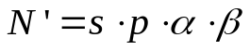 (2)
Because N/N′ ≈ s′/s/β < 1/β，the larger the network topology is (which implies a bigger value of β), the more improvement is achieved by SFabric.
Because of the considerable amount of total flow entries, in existing SDN solutions and traditional Ethernet, the core switches are very expensive due to their huge TCAM tables containing lots of switch states. Hence, the core switches become the bottleneck and restrict the network size. However in SFabric, switches in the access layers are always the software virtual switches, which can hold larger number of flow entries than the physical switches. Moreover, the core switches are directly facing access switches, so the number of flow entries in each core switch is a constant (s- s′) • s′, no matter how many hosts exist in the network. Since the flow entries of each switch are greatly reduced, SFabric obtains good scalability. And at the same time, the working load of DCFabric, including the maintainance of flow entries and the interactions with switches, is decreased obviously. Therefore, SFarbic makes DCFabric result in better efficiency, faster speed and higher throughput. As shown in Table 1, compared to traditional or existing SDN technologies, SFabric can help DCFabric handle more switches or hosts in a network and achieve faster speed.
 | Traditional technology | Exsiting SDN | SFabric
The number of switches | N*10 | N | N*100
The number of hosts | Thousands | Hundreds | Millions
Time to construct path | seconds | seconds | milliseconds
Table 1. The comparisons among different technologies
- Seamless cooperation with cloud computing platform OpenStack
Since DCFabric supplies the Neutron API that can support the newest Juno version for OpenStack, OpenStack is able to interact with DCFabric for processing management on network and addresses via the Neutron API. As a medium between OpenStack and lower forwarding devices (SDN switches), DCFabric affords many responsibilities of traditional forwarding equipments such as gateway, route, NAT and so on, which realizes centralized management and supports mixed networking between physical and virtual switches. Hence, as shown in Fig. 6, DCFabric can cooperate with cloud computing platform OpenStack seamlessly, realizing centralized management on network resource pooling, multi-tenant sharing and safe separation in layer 2 network. As a result, DCFabric can promote the service experience facing public cloud resource (i.e. virtual private cloud, (VPC)), provide technical guarantee of high throughput for supersized data centers and facilitate the development of cloud industry.
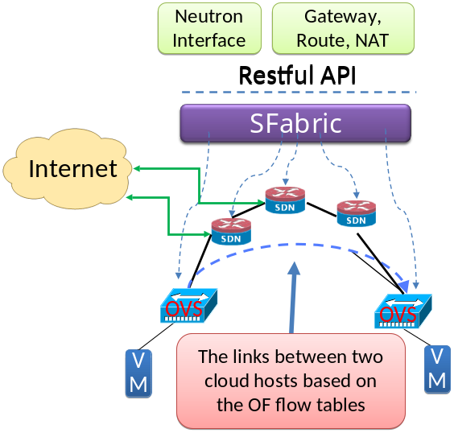
Fig. 6. The seamless cooperation between DCFabric and cloud computing platform OpenStack
- Providing typical APP SDK for data centers
  - Flexible traffic management
Traffic management is the most major advantage of DCFabric compared with other layer 2 technologies, which mainly includes:
    - Traffic download: to configure the properties of certain traffic (i.e. protocol type or destination address, etc.) according to specific requirements of application or management and install the flow entries into corresponding SDN switches for realizing the management on traffic.
    - Traffic lead: to separate the normal traffic from attack traffic for ensuring that the normal traffic will not be attacked.
    - Traffic rate-limiting: to limit the rate of a certain flow for achieving the management on the users or services with the help of authority or payment, which is realized through the Meter tables stored in the OpenFlow switches.
    - Traffic protection: to supply protection services (i.e. traffic migration) for improving the QoS of network, such as the requirements on rate and delay.
    - Traffic replication: to replicate a specific flow of a switch and send it to multiple destinations, which realizes the multicast function.
    - Traffic filtering: to filter the flows of a certain domain or the whole network for achieving the management that can distinguish the flows in the white list from those in the black list, which can reduce the risk created by illegal or unauthorized access and make the network safer.
In a word, once there is any change about the computing capability, storage resource or transmission bandwidth, DCFabric will dynamically adjust the network traffic from a global view, which is very useful to reduce power consumption, decrease network overhead, improve network service level and promote network resource utilization.
  - Uniform security application based on SDN
1) The customized elastic protection
Due to traffic perception, DCFabric can elastically update the security protection engine used for web application via API. Moreover, DCFabric is able to supply dynamic SDN network traffic lead technology to achieve safe filtering and supports the capability of setting up multi-layer and multi-variable traffic lead conditions, which can introduce security mechanism without changing any physical network topology and provide basic support for security application. DCFabric is conducive to reduce the cost, make the complexity of networking lower and realize the elastic deployment of security resource pool.
2) The fine-grained application level access control
In order to achieve security application, all kinds of application level access control mechanisms are needed. For instance, the process of identity authentication based on the certificate is to identify and authorize the devices or users according to network locations (MAC address, IP address or access port), and then the authorized examination should be executed according to the submitted resource access request. Once there is no problem with the authorization, corresponding route servers are informed to build temporary access paths for this access request.
3) Virtual security boundary
Because the static physical boundary in traditional network is replaced by dynamic virtual logic boundary, the security of intranet relies more on the security policy, the dynamic deployment, the configuration and management of facilities, as well as the perception, decision and response of the network security system for the traffic and services. Since DCFabric is able to implement centralized control and management on the network resource, DCFabric is good at dynamically managing the whole network. Except for being responsible for parts of security missions (i.e. access control list (ACL) or packet filtering firewall), DCFabric can work with other security management components to make decisions, alleviate security pressure and avoid accidents of boundary according to the network topology, congestion and security events.
4) Honeypot induction and moving target defense
The DCFabric and upper application programs can be united together to flexibly create honeypot for inducing attack or set up ever-changing moving target for increasing the difficulty and cost of attack, which can effectively cut down the probability of being attacked and promoting the elasticity of the network system.
- Supporting agile redevelopment
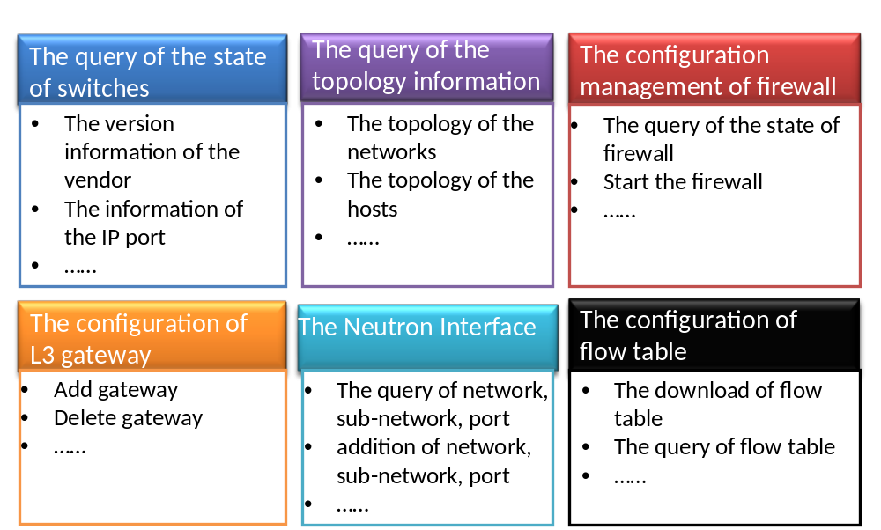
Fig. 7. DCFabric supports agile redevelopment
DCFabric is equipped with the southbound interface that supports OpenFlow and OVSDB, the northbound interface that supports UI development SDK based on HTML5, the effective APP development SDK and debugging tool (including system APP and Web APP, supporting C platform and bottomed code development). Therefore, as shown in Fig. 7, DCFabric supports the queries of switch state and topology information, the configurations of firewall and gateway, the management and maintenance of the flow entries and Neutron interface, which result in providing the view of the global resource abstraction of the network for upper applications. Consequently, DCFabric is able to shield the specific details of the network and make the network resource transparent to the applications, which finally make the control capability of the network no longer constrained by the hardware as well as provide convenience and support for agile redevelopment.
- Comparisons with other SDN Controller
 | ODL | ONOS | Ryu | MUL | FloodLight | Nox | Pox | Beacon | DCFabric
Openness | *** | *** | **** | **** | **** | *** | *** | *** | ****
Topological performance | **** | ** | * | **** | *** | ** | ** | *** | *****
Switch performance | *** | *** | *** | *** | * | * | * | * | *****
UI | **** | ** |  | ** | ** | ** | ** | ** | *****
Reliability | ** | ***** | * | *** | * | * | * | * | ***
Special application | OpenStack, SFC, SDNI, AAA | The multi-layer network, SDNIP | OpenStack, the separation of tenants |  |  |  |  |  | SFabric, OpenStack, Enterprise network
Application type | Core+Web | Web | Core+Web | Web | Web | Core | Core | Core | Core+Web
The development convenience | ** | **** | *** | *** | ** | ** | ** | ** | ****
Table 2. The comparisons with other SDN Controller
As shown in Table 2, DCFabric performs better than other existing SDN Controllers in terms of all kinds of properties, so it has stronger adaptability and can be redeveloped more simply, which makes it applied in more scenarios.
- Application prospect
- VPC service
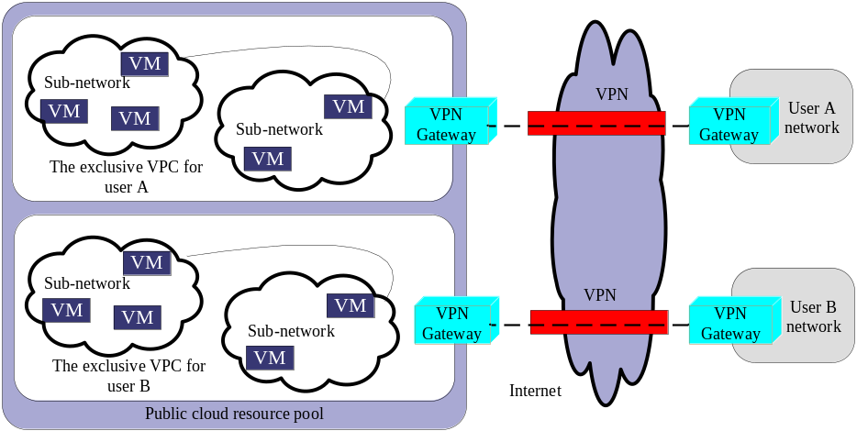
Fig. 8. The VPC service
Virtual private cloud (VPC) service can distribute a private area for each user from the public could resource pool, realizing the absolute resource separation among users in the layer 2 network. As shown in Fig. 8, each user can define the virtual network topology similar to traditional network in his exclusive area and have the complete right to control the virtual network circumstance. At the same time, each user can customize the network configuration of VPC easily and access his VPC by means of building VPN network. In many existing technologies, the VPC services are always implemented based on hardware, which leads to high price, difficult configuration and slow speed, etc. However, if DCFabric is employed, following advantages can be obtained:
        - All of SDN forwarding devices can be managed and controlled uniformly, which simplifies the network management.
        - The network resource pooling, multi-tenant sharing and safe separation in layer 2 network are supported. For instance, different user traffic can be distinguished according to the identification of layer 2, and then the forwarding strategies are made correspondingly.
        - The cross-domain VPC networking and access can be realized. For example, the VPN gateway of VPC and the user’s gateway cooperate with each other to realize the connection between VPC network and user network.
        - The virtually realized and value-added services of VPC network (i.e. firewall and load balance) can promote the performance of VPC network and make the requirement of networking satisfied.
        - The friendly UI used for management and control is provided to support user developing self-help management and configuration of the VPC resource, which realizes the uniform delivery of network resource, computation and storage in cloud computing.
The VPC technology and service based on DCFabric can meet users’ demands of the efficient utilization of cloud computing resource and the requirement that the VPC resource can be configured according to each user’s need, which is useful to improve users’ experience of cloud service further.
- Security services for Web APP
DCFabric realizes the Web security protection with the help of double security engines based on feature matching and anomaly analysis. The feature matching is used to detect and intercept the known attack types or techniques, and the anomaly analysis is employed for detecting abnormal Web access traffic or early warning unknown attack types or techniques. Moreover, DCFabric can elastically update the security protection engines for Web applications via API. Besides, DCFabric has the capability of guiding the traffic that needs to be filtered to the safe pool by means of traffic lead and virtual pooling technologies, which provides the guarantee of security services.
- Large layer 2 switching network of data centers
With the development of data concentration and the application of virtual technologies, the scale of data centers keeps rising, which not only requires the area of layer 2 network to be wider, but also challenges the demands and managements on the network. Although SDN performs well to construct large layer 2 network of data centers, in current existing SDN technologies, the forwarding behaviors of switches are controlled by the flow entries install by the Controller, which definitely brings heavy pressure on the working load of the Controller. However, since DCFabric is able to solve the problem mentioned above due to its efficient capability of constructing large scale network, DCFabric is suitable for building large layer 2 network of data centers.
- Elastic scheduling of the network resource
Because the load of applications is hard to be controlled and the network services are dynamic, the static integration of servers and the scheduling based on the virtual machine live migration are needed. Since DCFabric has the efficient working capability, provides typical APP SDK for device circumstance and supports agile redevelopment, it is suitable to schedule the network resource elastically. When a physical server is busy, DCFabric can move parts of work to another server; when the load of network services is not heavy, DCFabric can aggregate services so as to free several physical machines for saving power. The network sends the statistical data of the bandwidth to DCFabric regularly, and DCFabric can flexibly manage the network resource according to those data.
- Conclusion
DCFabric is the first open source SDN Controller in China. Our object is to propose a practical open source SDN technology for data centers. The main advantages of DCFabric are:
        - Compared to other existing SDN Controllers, DCFabric has better flexibility, stronger reliability, higher intelligence, larger throughput and shorter delay.
        - DCFabric can cooperate with cloud computing OpenStack seamlessly via its northbound interface, which results in supporting all kinds of Web applications, simplifying the construction of new service and providing convenience for the development of Web applications.
        - Due to the southbound interface, DCFabric can not only control the forwarding equipments based on OpenFlow protocol, but also be compatible with traditional network devices.
Our work is useful for the progress of the independent innovation of SDN technology in China. Furthermore, the work can promote the developments of cloud computing and data centers significantly.

